Jai Shri Ram

1. throughput

throughput is the number of transactions a system can handle in a given time period

In performance testing, throughput is a measure of how many requests a system can handle in a given amount of time. It's often measured in transactions per second (TPS).

**Throughput define the number of transaction per second (tps)**

1. Concurrent users - **Means Multiple users**

Concurrent users mean multiple users doing parallelly work into application.

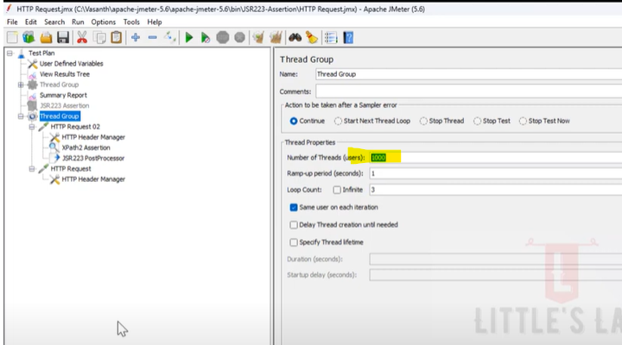

1. Thread dump / Heap dump / Garbage Collection Log

Heap dumps = Heap dumps contain information about the objects in Java Virtual Machine's (JVM) memory, their values, and their sizes. Heap Dump is used for troubleshooting memory related, OutOfMemoryError.

Thread Dump is used to check whether you're stuck in a deadlock condition. Heap Dump is used to detect memory leaks.

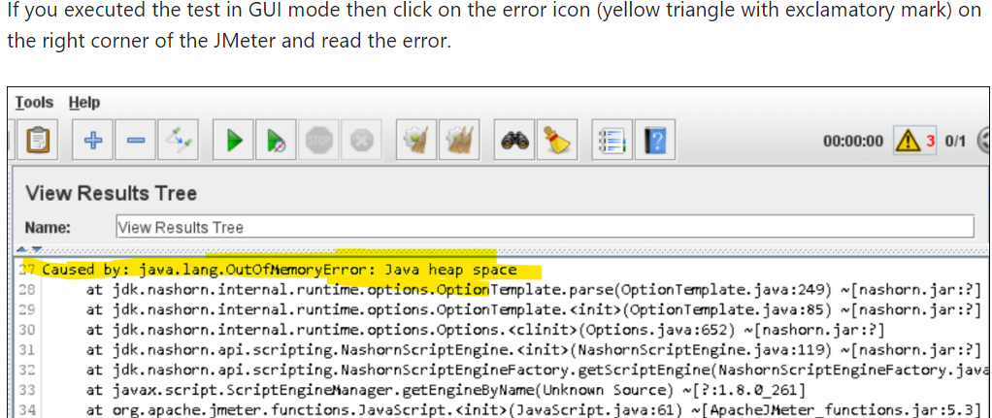

Thread Dump = All threads running in the application at a same point in time. It contains all the information about each thread in the application such as thread state, thread Id, native Id, thread name, stack trace, and is used to check whether you're stuck in a deadlock condition

Garbage Collection Log

A garbage collection **log** records data and statistics about Java garbage collection. Log files can reveal when GC last ran, how long the process lasted, how many objects were promoted, how much memory was reclaimed, and other useful information.

**A Garbage Collection is a log that contain all objects related information, objects means memory related information so that’s why we called it automatic memory management, it can impact the performance of application in many ways. Its can be memory fragmentation, cpu load.**

Garbage collection (GC) is a form of **automatic memory management** that can impact application performance in many ways. it’s can be Memory fragmentation, CPU Load

Too many GC cycles degrade the performance of the system and cause a spike in CPU whereas a delay in GC cycles leads to memory leakage.

**The Best Garbage Collection for JMeter: Automated memory management is one of the core features of Java. By default, JMeter uses the G1GC algorithm to clean up the unreferenced objects in the heap**

1. **Deadlock:** A deadlock is a situation when two or more threads are waiting for the other threads to complete their tasks in order to complete their own tasks. To identify the root cause of the deadlock, a threads dump is required.
2. Response Time / Latency / Throughput

<https://youtu.be/Ngzi_4ToVJg>

<https://youtu.be/xcrY0DFF8UQ>

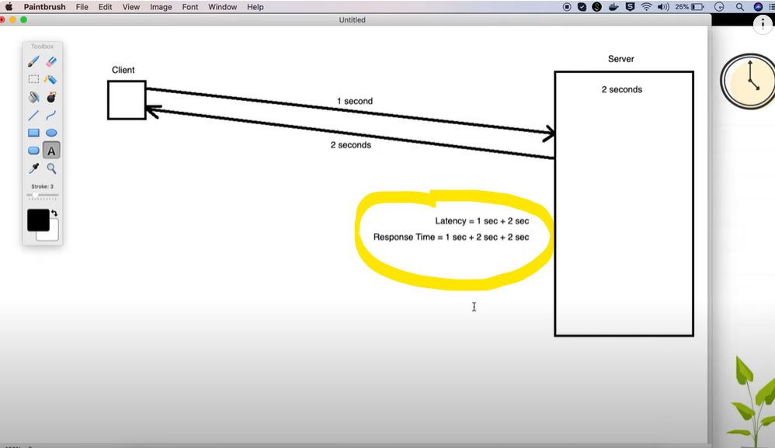

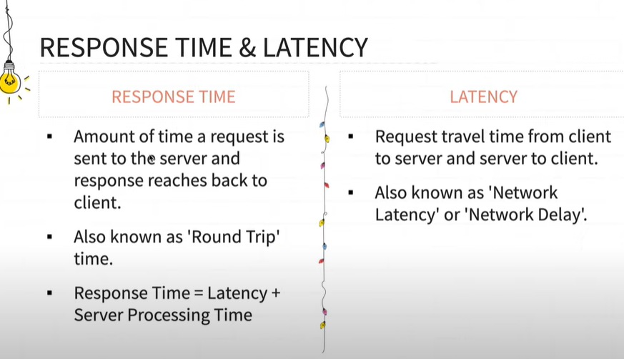

Response time - Response time is amount of time **a request is sent to the server and server process that request and gives back to the client**

**Response Time** = Latency + Server processing Time

**Latency / Network Delay / Network Latency** - Request Travel time from client to server and server to Client

Let us know understand the why the latency and response time are important in performance testing

If your application is under test and your load generator machine is in same network than you will not face any latency issue as both in are same network and if your application is on production and user is accessing your application different geographical location than in case you will get different latency value so hence we should consider latency value in performance testing

**Throughput** = Throughput is number of transactions per second an application can handle

Throughput generally known by Request Per Second (RPS), Transaction per second (TPS), Hits per Second

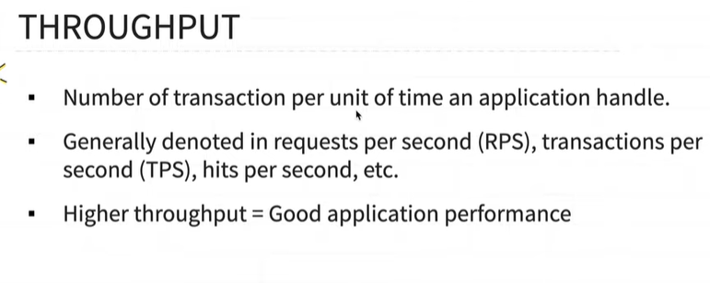

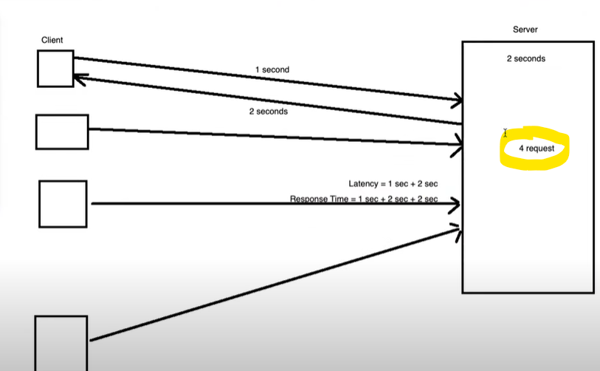

1. **Ramp Up, Ramp Down and Steady State**

[**https://youtu.be/7wcX_sYrbzU**](https://youtu.be/7wcX_sYrbzU)

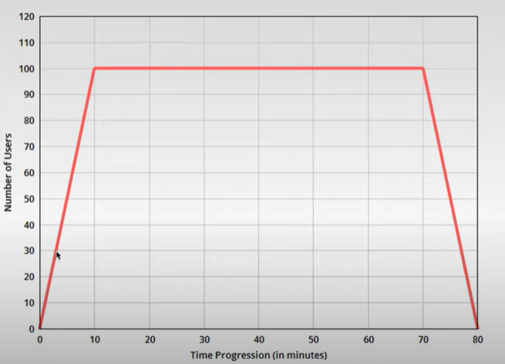

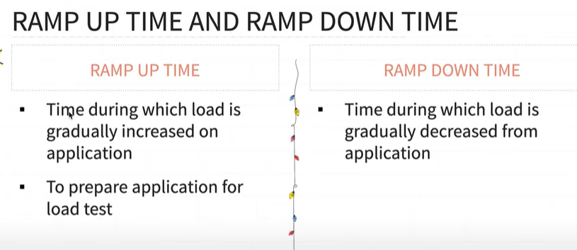

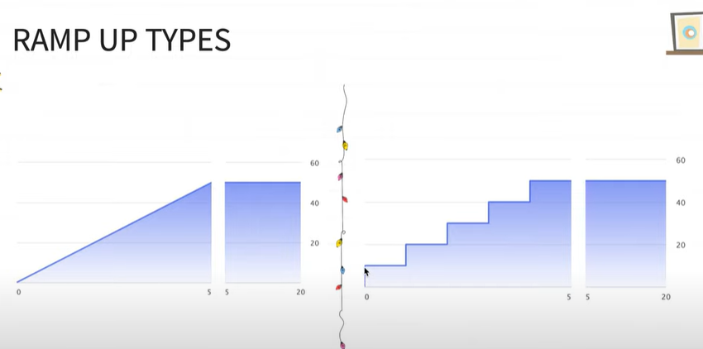

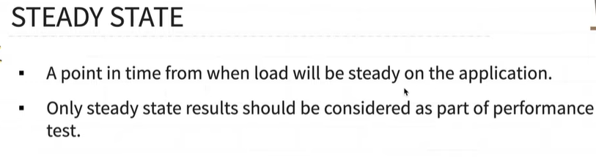

1. **Think Time and Pacing in Performance Testing**

[**https://youtu.be/5K_kW10f6iM**](https://youtu.be/5K_kW10f6iM)

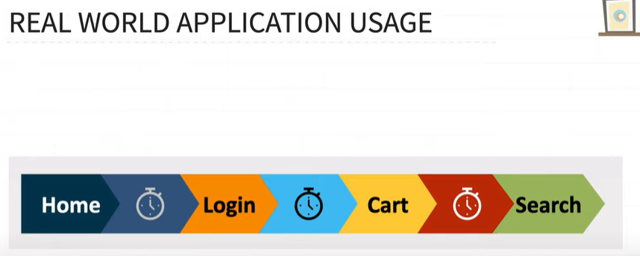

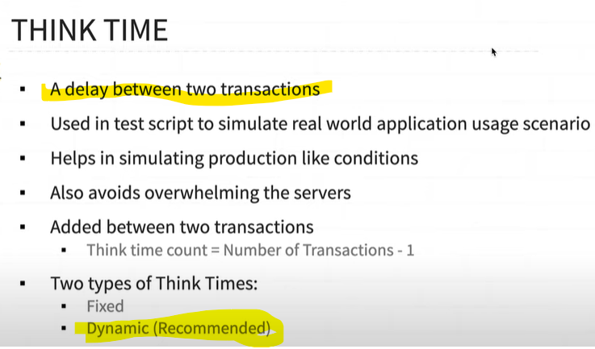

Think Time - Think Time is a **delay between two transactions**, we should use Think Time in our Test Script to get realistic result, if we not use Think time than your application will give incorrect performance test result

Two Type of Think Time

1. Fixed – Fixed means constant (we used Constant Timer for this)
2. Dynamic (Recommended) – Dynamic means value change dynamically (we used Uniform Random Timer for this)

Pacing - pacing is a **delay between two iterations**

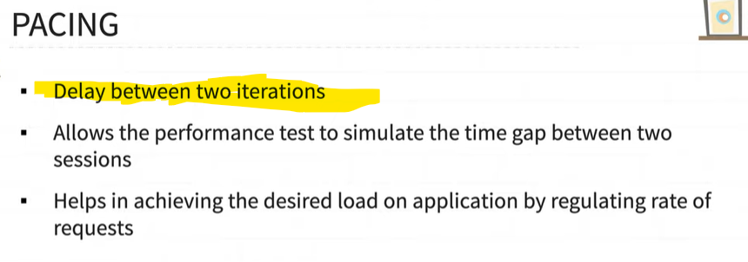



When your one iteration is complete after that will be some delay before to start next iteration so the **delay between two iteration is called pacing**

What is baseline and benchmark testing and difference

The Difference of Baseline and Benchmark Testing is in a baseline testing we compare the test result with previous performance test result whereas in benchmark we compare the application performance result with competitors or other companies application performance result

**What is baseline testing?**

Baselining compares it to your own historical performance.

Or

Baseline compares application's current performance with its previous performance.

**What is benchmarking testing?**

Benchmarking compares it to competitors or peers.

Or

Benchmark compares application performance with other companies’ application's performance.

What is Aggregate report in JMeter

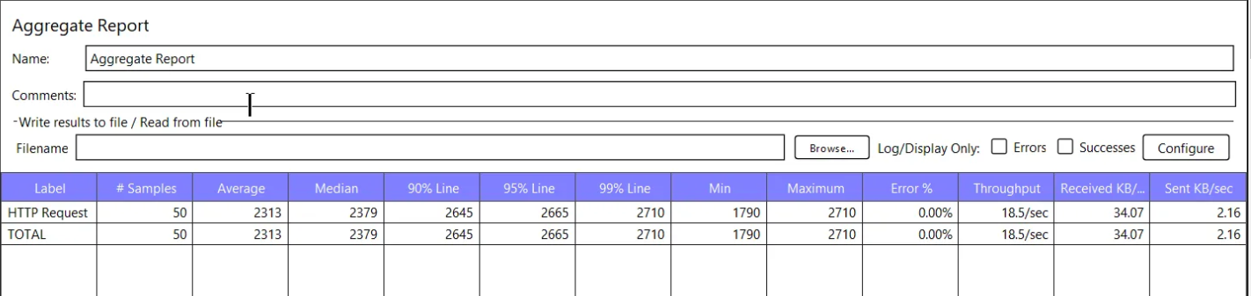

**Samples** - sample is a total number of users what we defined on thread group

**Average** - this is average time of these sample

**Median** – median means 50% of the request time

**90%** **percentile** - this time means 90 percentiles of request has been successfully executed

The 90% percentile in JMeter that represent the 90 percentage of request to be completed successfully

In jmeter, the 90 Percentile metric is used to measure the response time of a particular request during a load test. It indicate the 90 % of request has been successfully completed while in the remaining 10 request may have bigger response time

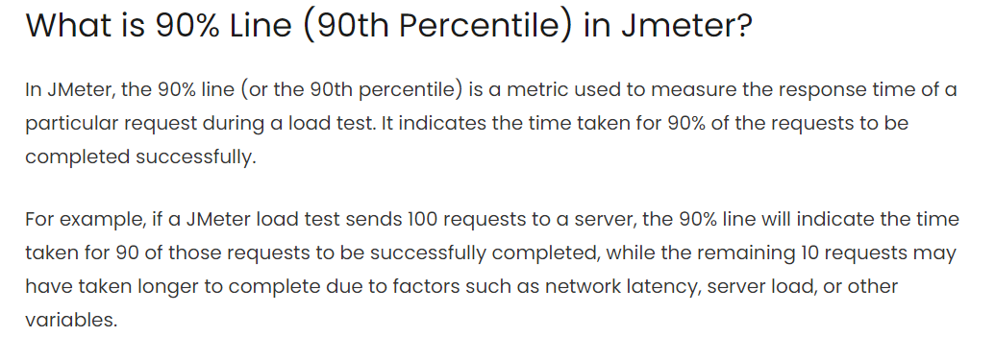

**What are the exiting and entering criteria in the performance testing?**

**Entry Criteria:**

1. Build/application should be stable (stable means functionality should be well and good, not functionality bugs should exits)  
2. Performance testing environment should be ready  
3. Scripts should be ready

**Exit Criteria:**

Performance execution should be finished without any transaction failures.

Random CSV Data Set

average response time

Load testing and scalability testing